**OOPM : LAB 11**

Output

**Name :** Gini Chacko

**Batch :** B

**Roll No :** 8942

1.] Add Task

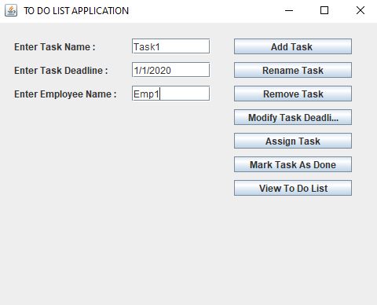

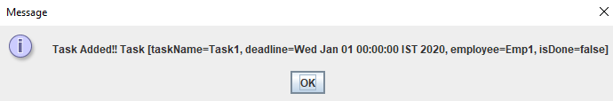

Inside createTask()

Inside display the toDoList()

The task Name Task1 is assigned to Emp1 is given deadline as Wed Jan 01 00:00:00 IST 2020 having status as false

2] Rename Task

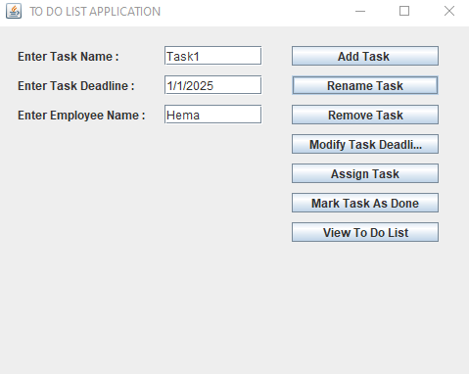

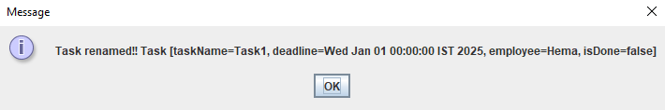

Inside renameTask :Task1

inside

[Task [taskName=Task1, deadline=Wed Jan 01 00:00:00 IST 2025, employee=Hema, isDone=false]]

Inside display the toDoList()

The task Name Task1 is assigned to Hema is given deadline as Wed Jan 01 00:00:00 IST 2025 having status as false

3.] Add Task

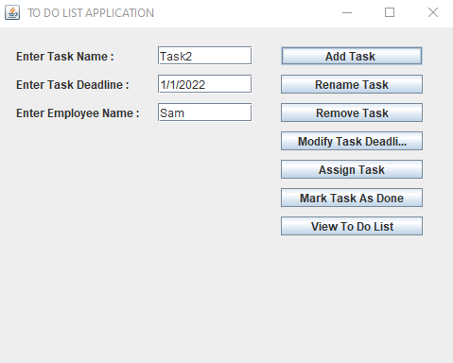

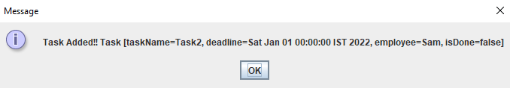

Inside createTask()

Inside display the toDoList()

The task Name Task1 is assigned to Hema is given deadline as Wed Jan 01 00:00:00 IST 2025 having status as false

The task Name Task2 is assigned to Sam is given deadline as Sat Jan 01 00:00:00 IST 2022 having status as false

4.] Add Task

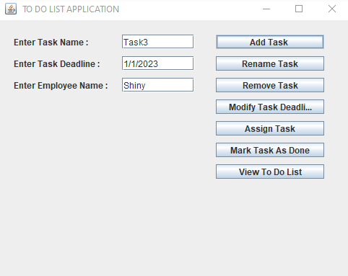

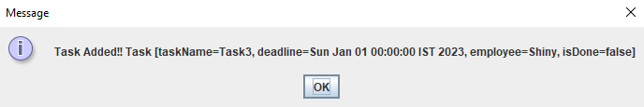

Inside createTask()

Inside display the toDoList()

The task Name Task1 is assigned to Hema is given deadline as Wed Jan 01 00:00:00 IST 2025 having status as false

The task Name Task2 is assigned to Sam is given deadline as Sat Jan 01 00:00:00 IST 2022 having status as false

The task Name Task3 is assigned to Shiny is given deadline as Sun Jan 01 00:00:00 IST 2023 having status as false

5.] Modify Task Deadline

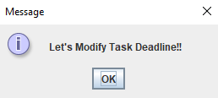

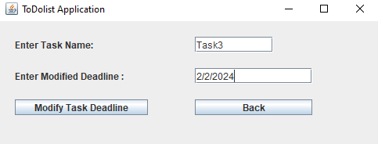

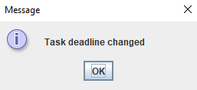

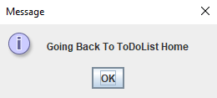

Inside modifyDeadline()

Task Deadline modifies Succesfully

Inside display the toDoList()

The task Name Task1 is assigned to Hema is given deadline as Wed Jan 01 00:00:00 IST 2025 having status as false

The task Name Task2 is assigned to Sam is given deadline as Sat Jan 01 00:00:00 IST 2022 having status as false

The task Name Task3 is assigned to Shiny is given deadline as Fri Feb 02 00:00:00 IST 2024 having status as false

6.] Assign Task

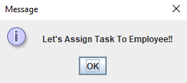

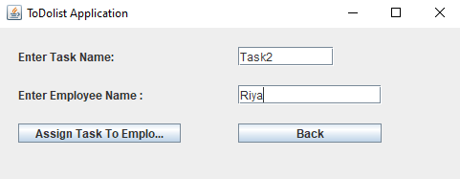

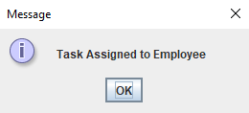



Inside assignDeadline()

Task Assigned to Employee Sucessfully

Inside display the toDoList()

The task Name Task1 is assigned to Hema is given deadline as Wed Jan 01 00:00:00 IST 2025 having status as false

The task Name Task2 is assigned to Riya is given deadline as Sat Jan 01 00:00:00 IST 2022 having status as false

The task Name Task3 is assigned to Shiny is given deadline as Fri Feb 02 00:00:00 IST 2024 having status as false

7.] Mark As Done Task

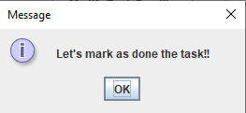

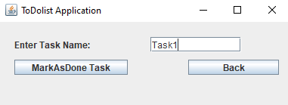

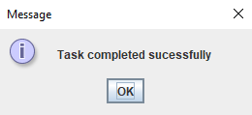



Inside markAsDone()

Task Marked As Done Successfully

[Task [taskName=Task1, deadline=Wed Jan 01 00:00:00 IST 2025, employee=Hema, isDone=true], Task [taskName=Task2, deadline=Sat Jan 01 00:00:00 IST 2022, employee=Riya, isDone=false], Task [taskName=Task3, deadline=Fri Feb 02 00:00:00 IST 2024, employee=Shiny, isDone=false]]

Inside display the toDoList()

The task Name Task1 is assigned to Hema is given deadline as Wed Jan 01 00:00:00 IST 2025 having status as true

The task Name Task2 is assigned to Riya is given deadline as Sat Jan 01 00:00:00 IST 2022 having status as false

The task Name Task3 is assigned to Shiny is given deadline as Fri Feb 02 00:00:00 IST 2024 having status as false

8.] Remove Task

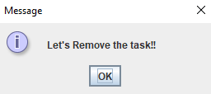

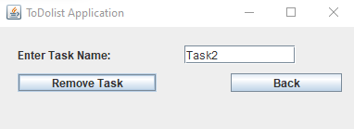

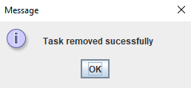



Removing an existing Task

Task deleted successfully

Inside display the toDoList()

The task Name Task1 is assigned to Hema is given deadline as Wed Jan 01 00:00:00 IST 2020 having status as true

The task Name Task3 is assigned to Shiny is given deadline as Fri Feb 02 00:00:00 IST 2024 having status as false

9.] View To Do List

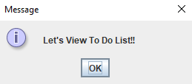

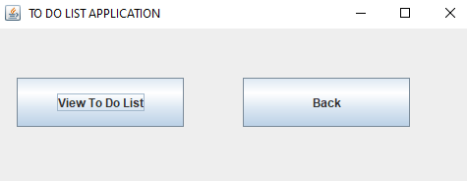

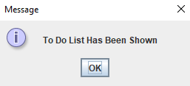



Inside display the toDoList()

The task Name Task1 is assigned to Hema is given deadline as Wed Jan 01 00:00:00 IST 2020 having status as true

The task Name Task3 is assigned to Shiny is given deadline as Fri Feb 02 00:00:00 IST 2024 having status as false